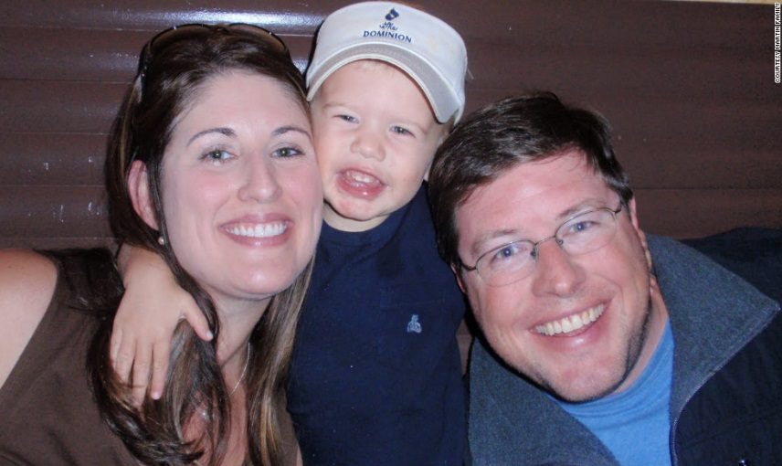
On July 5, 2011, my husband and I were told that our 2-year-old son has an invisible killer living inside his body.
Just a few short years ago, I was happily pregnant. Now, suddenly: Why? What? When? All these questions came with so few answers about a disease that few know about or understand.
That invisible killer is called mitochondrial disease. Our son's specific mutation is called Leigh's Disease.
We're one of the lucky ones. It took us only a year to get a diagnosis -- a year filled with anesthesia, a CAT scan, a muscle biopsy, a lumbar puncture, an MRI, an echocardiogram, an EKG, specialists and so on. Most families spend years attempting to find a diagnosis because of the complexities of DNA sequencing.
This silent killer is attacking our nation's children at an appalling rate. According to the United Mitochondrial Disease Foundation, every 30 minutes a child is born who will develop a mitochondrial disease by age 10.
As a first-time mom, I had no idea that I should have been scared of mitochondria. All I knew was some fuzzy science from high school biology about mitochondria being the powerhouse cells of our body.
Mitochondria are responsible for creating more than 90% of the energy needed by the body to sustain life and support growth. When they fail, less and less energy is generated within the cell. Cell injury and even cell death follow.
If this process is repeated throughout the body, whole systems begin to fail, and that person's life is severely compromised. The disease primarily affects children, but adult onset is becoming more common.
We were told that diseases of the mitochondria appear to primarily damage cells of the brain, heart, liver, skeletal muscles, kidney and the endocrine and respiratory systems. (Excuse me, but what's left?)
Symptoms may include loss of motor control, muscle weakness and pain, gastrointestinal disorders and swallowing difficulties, poor growth, cardiac disease, liver disease, diabetes, respiratory complications, seizures, visual or hearing problems, lactic acidosis, developmental delays and susceptibility to infection.
Mitochondrial disease is similar to cancer in the way it presents itself -- it can manifest in many forms.
Our son currently presents classic Leigh's symptoms: He has four brain lesions near the deep cerebellum. As his body is attacked with viral infections, fever or even as he gets overheated, he is at risk for additional brain damage that ultimately will result in system failures.
My husband and I were told on July 5, 2011, that our son will die an early death. There are no treatments; there is no cure. We left the doctor's office with instructions to start the "mito cocktail" of supplements, continue with therapy and keep him from getting sick.
We also left the doctor's office with a huge, gaping hole in our hearts. Within a matter of seconds, this huge piece was ripped out and we still haven't quite figured out how to put it back together. Our hearts are bigger now -- we can accept more and give more -- but I don't think the hole will ever mend.
It's National Mitochondrial Disease Awareness week. For us, every day we're deeply aware -- our son is lucky.
Our doctor says he has a mild case of what will one day kill him. We get to hear him say, "I love you" and watch him laugh with friends. So many other "mito" kids can't even roll over, swallow their food or see their favorite "Veggie Tales" character on TV.
There are a lot of days I don't feel so lucky. But then this tow-headed goofball comes barreling at me wanting to give me a bear hug (complete with sound effects) and it snaps me out of my sadness.
My son is my hero. He pushes us to keep going. He is the one enduring endless blood draws, hospital stays and experimental drugs.
There is no cure, but there is hope. Recently, Edison Pharmaceuticals received orphan status for the drug EPI-743. We're one of 128 people in the world who somehow managed to get a spot in their research program.
Essentially, the drug is supposed to help Will's mitochondria function better, giving him increased energy and a chance at a better quality of life.
I often find myself feeling guilty that we're on it when there are so many others who should be. Likely, by the time the Food and Drug Administration approves it, many of these children will perish. It's not a cure, but it is a sign of hope.
You might be wondering how you can help. The first thing I would suggest is to get informed. Organizations like the United Mitochondrial Disease Foundation or websites like Mitoaction.org are good starting places.
Second, get involved. Find your local UMDF chapter and join one of the Energy for Life walks.
And lastly, you probably know someone whose child suffers from a silent or chronic disease -- autism, diabetes, multiple sclerosis, mitochondrial disease or cancer. We all just want to be "normal." A hug, a kind note of support or just a friendly smile at the grocery store goes a long way.

