Name: ________________
From Marshmallows to Molecules
Objective: Draw Marshmallow Molecules made during Marshmallow lab as Bohr and Lewis Dot Atoms. Understand types of bonds.
Materials: Marshmallow Molecule Lab, Notes, and pencils
Procedure: Using the marshmallow molecules, your periodic table, and your notes, draw the molecules below as a marshmallow molecule, bohr molecule, and lewis dot molecule.

Draw a model of the molecules formed. Be sure to label and or color
Marshmallow Molecule  Ex) Water – H₂O | 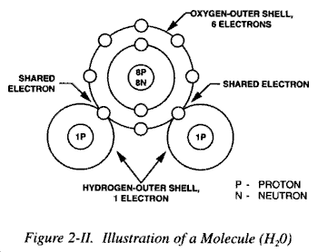  Bohr Molecule  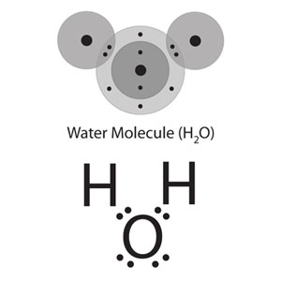 | 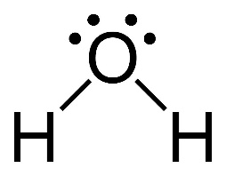  Lewis Dot Molecule

Compare and contrast the marshmallow molecule to the Bohr and Lewis Dot Molecule: __________________________________________________________________________________________________________________________________________________________________________________________________________

How many electrons make a full first orbit (look at the Hydrogen atom): ____________

How many electrons make a full second orbit (look at oxygen): _____________

Do Hydrogen and Oxygen both have a full outer orbit? Why or why not? _____________________________________________________________________________________________________

When Hydrogen and Oxygen bond and create a water molecule (H2O) are their outer orbits full? Why or why not?
_____________________________________________________________________________________________________

Complete the chart
Marshmallow Molecule | Bohr Diagram | Lewis Dot
Hydrogen – H2 (covalent bond)
Ammonia – NH3
Carbon dioxide – CO2 (double bond)
Methane – CH4

Draw the Bohr and Lewis Dot Molecules for the following.
1. H2O | Hydrogen-H2 | Nitrogen Gas-N2 | Carbon Monoxide- CO
2. H2O2 | Oxygen- O2 | Ozone- O3 | Sodium Chloride -NaCl
3.C12H22O11 (3 pts) |  | Carbon Dioxide- CO2 | Hydrochloric Acid-HCl
 |  | Carbonic Acid- H2CO3 (2 pts)
4. CH2O |  | Sodium Hydroxide- NaOH
5. CHNO (2 pts) |  | Ammonia- NH3

