Evolution Notes
Evolution is just a “theory” isn’t it? Yes it is…But what is a theory anyway?
- Popular definition of a theory – a __________ or “hunch”
- Scientific Definition of a Theory – a well-substantiated ________________ of an aspect of the natural world.
- Scientific Theories are based on ___________, facts, and have been ________ in many ways.

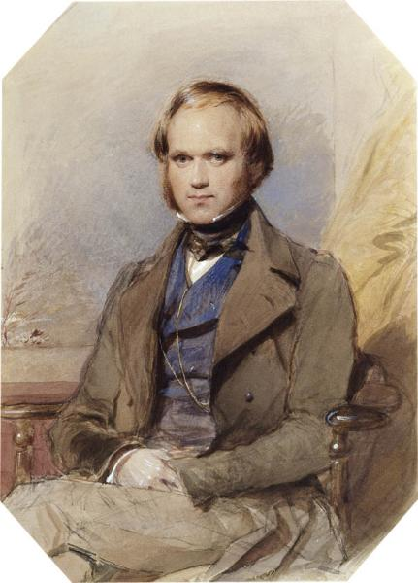
Where did the Theory of Evolution come from?
- The theory of evolution was thought of by both __________ __________ and _________ _________ __________.
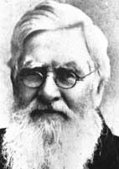
- Charles Darwin studied traits of organisms on the _____________ Islands and developed the theory of evolution by __________ __________.
- Alfred Russell Wallace studied traits of organisms on the ________ Archipelago of islands and coined the term __________ ____ _____ __________.

What is Evolution?
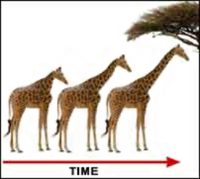
- Evolution is the process of species __________ _______ ________ to better suit their environment.
- Species: a group of organisms that can _______ with one another
to produce _________ offspring.
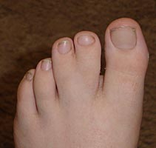
- Species change over time because of _____________ and __________ ____________.
- Mutations: __________ to an organism’s DNA made during ___________.
- Mutations create ____________ in a population.

Natural Selection
- In Natural Selection organisms with favorable _________ best suited to their environment are more likely to ___________ and ______________.
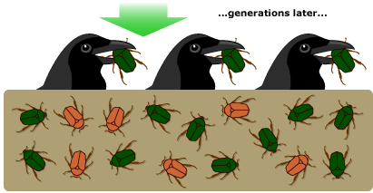
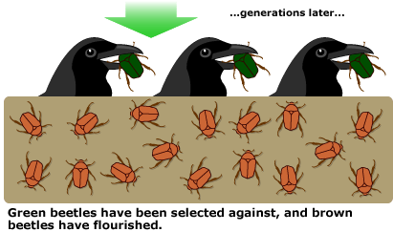
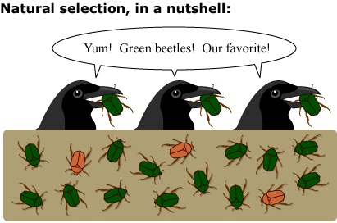

The Process of Natural Selection
- Overproduction: organisms in a population produce more ____________ than their environment can support.
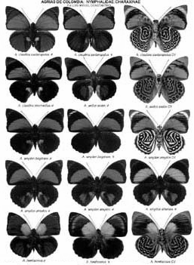
- Not all offspring will ___________ long enough to reproduce.
- There must be ____________ within the species.
- Variation: ____________ among _______ between individuals of the same species.
- Variations must be ____________ from an organism’s parents.
- Organisms ___________ to __________ in their environment.
- Starvation, ___________, competition & ____________ limit populations of all species.
- Organisms that survive the struggle have __________ variations of ________ (adaptations) that help them ___________.
  - Adaptations: features that make an organism suited for its ________________ so it can survive, ______________, & pass its genes/alleles onto its offspring.
- Selection (successful reproduction): The members of a population that have ___________ helpful variations of traits will be more likely to ___________ and _____________.
How do new species form?
- That’s called ______________: the formation of a new species as a result of evolution
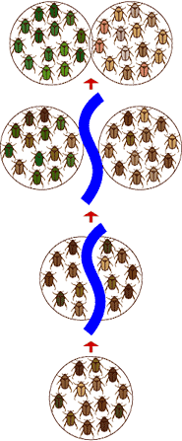
- Speciation occurs when _____ species _________ into _____ different ________ that can’t reproduce with each other anymore. Three events often lead to speciation.
      - Separation - when a ________ of individuals becomes ____________ from the rest of the population. Can be _________ by a newly formed canyon, mountain range, lake or _____________ of Earth’s tectonic _________.
      - Adaptation - Separated __________ continue to be __________ by natural ____________ in their new, different environments. ____________ _______ can be __________ and over many generations can _________ through the population.
      - Reproductive Isolation - Over time the separated ______________ can become so different that they may _____ be able to ________ _______________ with each other anymore. The populations are now considered to be ______ _____________ _________.

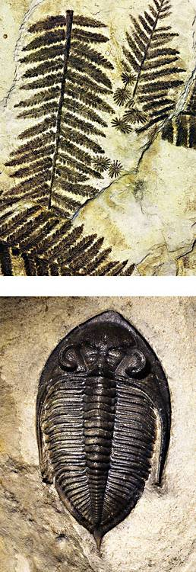
The Evidence for Evolution
Fossil Evidence
- The ________ _________ is all of the fossils that have been found.
- By _____________ the fossil record we can see what lived in the past.
- Comparing organisms in the fossil record provides evidence for how organisms have __________ ________ ________.

Biological Evidence
- Embryology – The study of early development in _____________.
  - During early _______________, the embryos of a shark, a rabbit, and a gorilla look similar. This suggests an evolutionary ______________ among all vertebrates.

- Homologous Structures – similar structures with _____________ functions
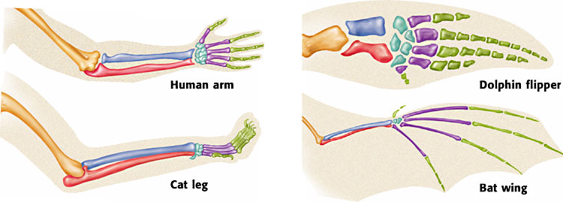
  - The _______ ____________ of the human arm, the front leg of a cat, the front flipper of a dolphin, and the wing of a bat are all __________.

- Vestigial Organs/Structures – They show how some modern ______________ are related to ancestors.
  - For Example: Whales have small ______ bones.

Genetic Evidence (DNA)
- Scientists can tell how closely organisms are related by _____________ their _______.
- The more __________ the DNA, the more closely ___________ the organisms are (possibly evolved from common ancestor).
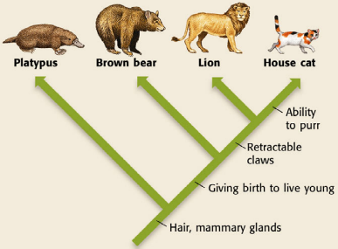

How do we show evolutionary relationships?
  - Use ___________ __________ to show how organisms are related.
  - Branching diagrams (cladograms) show which _______________ organisms _________ and when these organisms ___________.
  - Organisms are __________ in the diagram by their __________ ___________ ___________________.
  - Derived characteristic: a _______ that two or more kinds of _____________ _________ with their most recent common ____________.
  - The ________ derived __________________ organisms share, the ________ closely ___________ the organisms probably are.
  - Each characteristic listed on the diagram is only _________ by the ____________ _______ it.
  - Characteristics shown _________ on the ____________ are more __________ than the characteristics below them.

