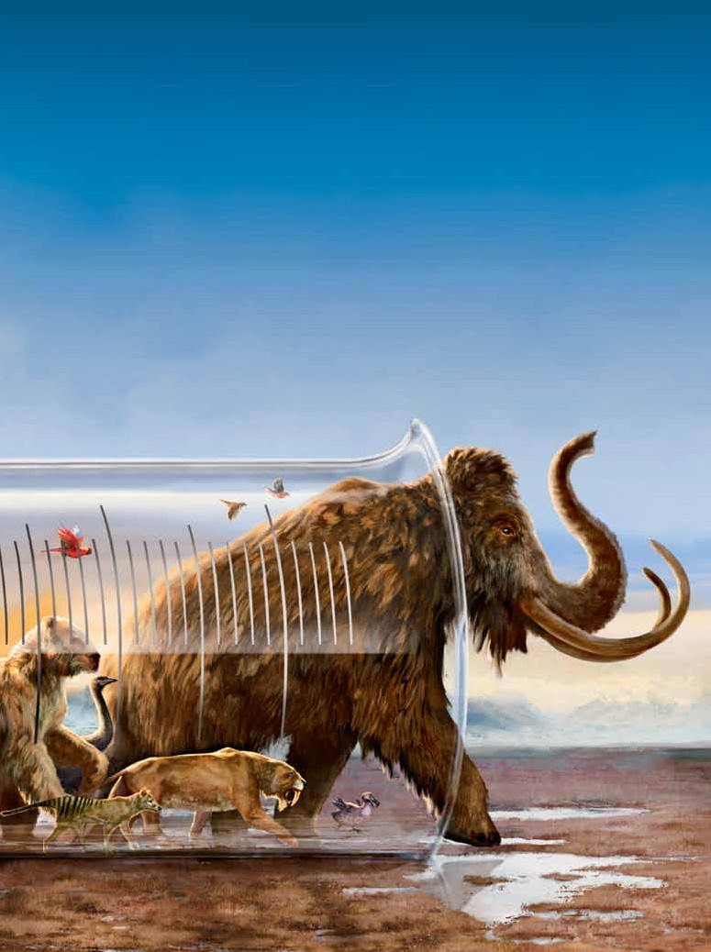
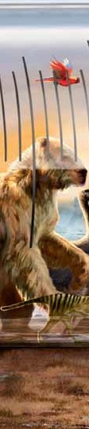
Biology: Genetics // Chemistry: Biochemistry //
earth sCienCe: Environment // PhysiCs: Technology
Backfrom
dead
the
should scientists bring extinct species back to life?

1 Science World • www.scholastic.com/scienceworld
Jon Foster/national GeoGraphic stock

ntil the 1980s, Australia was home to a very odd amphibian: the gastric-brooding frog. The strange thing about this frog was that the female laid her eggs in water, and
U
once the male fertilized them, she swallowed the eggs whole. Her tadpoles grew inside
her stomach. When the baby frogs were fully developed, the mother burped them out of her mouth!
This strange species fascinated scientists. But soon after researchers discovered gastric- brooding frogs in the early 1980s, a fungal infection wiped all of them out. The species became extinct.
Now, three decades later, the gastric- brooding frog may come back to life. Scientists are trying to use biotechnology— the artificial manipulation of living things—to resurrect the baby-burping frog, as well as species that have been extinct much longer.
“Just imagine looking at a saber-toothed cat, or a woolly mammoth, or a giant ground sloth—things our ancestors saw,” says Hank Greely, a bioethicist at Stanford University in California. “That’s plausible now.”

reviving a species
Why bring back extinct species? One reason is to increase biodiversity, which has
declined in many areas as species die off.

natural disasters, disease outbreaks, or climate change.
“All of these ‘de-extinction’ projects are focused on trying to increase the complexity and diversity of the natural world,” says Mike Archer, a paleontologist at the University
of New South Wales in Australia. Archer is leading the team that’s trying to bring back the gastric-brooding frog.
When Archer set out to revive the frog
5 years ago, the first thing he needed was an intact nucleus from one of its cells. Nuclei contain an organism’s DNA. This chemical carries the hereditary information that determines an animal’s traits.
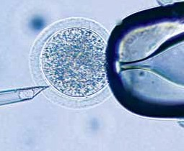
Scientists have been using nuclei from living animals to create clones, or genetically identical copies, of those animals for many years (see Cloning Timeline, p. 3). But when an animal dies, its cells decompose and the DNA inside its nuclei begins to break down.

eGG

watCh a video online
www.scholastic.com
/scienceworld

4 Bonus skills sheets
www.scholastic.com
/scienceworld

Dna transFer: Under a microscope, a researcher injects
an egg with genetic material to create a clone.

When an ecosystem has a wide variety of animals and plants, there’s a better chance that at least some of them will survive
a pipette injecting genetic material
a pipette holding the egg in place

How to Make a wooLLY MaMMotH
scientists may be able to use a frozen cell from a mammoth that’s been dead for thousands of years to bring the
species back from extinction. an elephant—the mammoth’s closest living relative—would carry the baby clone.

mammoth nUcleUs
elephant eGG

1 isolate the nucleus of a
viable mammoth cell from a frozen carcass.

2 Remove the nucleus from the
egg of an elephant and replace it with the mammoth nucleus.

3 Chemically or electri-
cally stimulate the cell to make it begin dividing.

4 Place the egg in the uterus
of an elephant. it will take almost two years to develop.

5 if the pregnancy
is successful, the elephant gives birth to a baby mammoth.

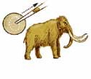
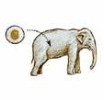
PhiliPPE Psaila/sCiENCE sOURCE (EGG); FERNaNdO G BaPTisTa,/NaTiONal GEOGRaPhiC sTOCk (BOTTOm)
to order, call 1-800-scholastic 2

mammoth mUmmY: this baby mammoth’s body, discovered under permafrost in siberia in 2007, still had some Dna inside.

This makes cloning an extinct species much harder than cloning a living one.
Luckily, back in the 1970s, another scientist had frozen some gastric-brooding frog tissue and saved it. Archer examined cells from the frozen sample and was excited to find that their nuclei appeared intact.
The next step was to find an egg. In traditional cloning, scientists take an egg cell from a female of the same species and
remove its nucleus. Then they replace it with the nucleus of a regular cell from the body
of the individual they want to clone. When the egg starts to divide, the new cells contain copies of the donor animal’s DNA.
But no one had saved any gastric-brooding
frog eggs. That meant Archer had to try
something else: inserting the cell nucleus of the extinct frog into the egg of another species. He started collecting eggs laid by great barred frogs, a common species in Australia.
Over the next few years, Archer’s team injected thou- sands of great barred frog eggs with gastric-brooding frog nuclei. None of them grew. But the researchers kept trying and adjusting their technique.
Finally, about two years ago, one of the eggs started dividing. When Archer tested the growing ball of cells, or embryo, he found gastric- brooding frog DNA inside.
“That told us that the extinct animal’s DNA was driving the devel- opment of a new frog,” he says.

de-extinction plans
So far, none of the eggs have grown past the embryo stage into baby frogs. Archer and his colleagues aren’t sure why. But if they can solve that problem, says Archer, “I’m hopeful that within a few years we should have this frog back.”
Archer’s attempt is the farthest along, but other teams of scientists want to use similar techniques to bring back other extinct species, like the woolly mammoth. These
hairy relatives of elephants roamed the frozen tundra of Siberia until they died out about
5,000 years ago. Scientists have found many

cLoning tiMeLine scientists first cloned
animals more than 60 years ago. since then, breakthroughs in cloning technology have brought them closer to being able to revive extinct species.

1952
scientists create the first cloned animal—a tadpole—by extracting a cell nucleus from a developing embryo and inserting it into an egg that has had its nucleus removed.

1996
Dolly the sheep, the first mammal cloned using the body cell of an adult animal, is born in scotland. dolly becomes famous and brings lots of attention to cloning.

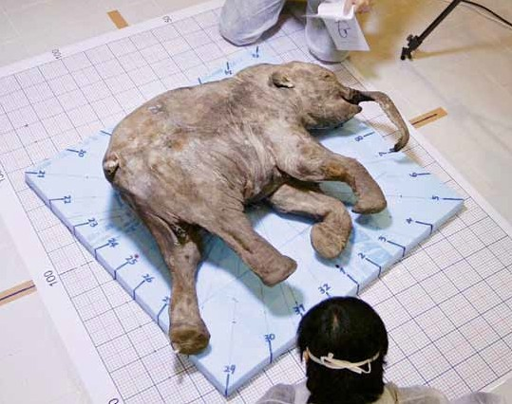
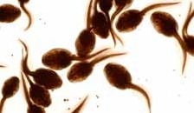
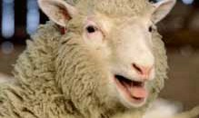
Ria NOvOsTi/aFP/GETTy imaGEs (TOP); ThiNksTOCk (1952); JEFF J miTChEll Uk/REUTERs (1996)
3 Science World • www.scholastic.com/scienceworld

buried mammoth fossils and, in a few cases, the frigid conditions have helped preserve some DNA. A group of South Korean and Russian researchers hopes to use this material to bring mammoths back to life one day (see How to Make a Woolly Mammoth, p. 2).
Ben Novak, a biolo- gist at the University
of California, Santa Cruz, wants to use genetic techniques to bring back the extinct passenger pigeon. These sleek, gray-blue birds used to flock over the Northeastern U.S. in groups of a billion or more. But by the late
1800s, they had been

cominG Back? the gastric- brooding frog, now extinct,
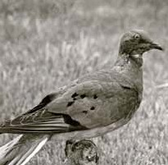
birthed babies through its mouth.

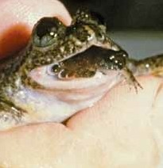
Gone For noW: passenger pigeons were hunted to
extinction in the 1800s.
scientists working on these projects should
be very careful. Many of the environments that extinct species once inhabited have changed since they lived there,
he says. If a long-gone species is reintroduced, it could become an invasive species that upsets the current ecosystem.
Some conservation- ists also worry that if scientists can bring extinct animals back, no one will care about keeping endangered species from becoming
extinct in the first place. “If this were to
undercut efforts to conserve currently
existing species, that

Core

hunted to extinction by trappers who sold
would be a tragedy,” says Greely.
Question

them for people to eat. Bringing them back
Archer doesn’t think that will happen. In

would help restore biodiversity to the forest ecosystems in which they lived, says Novak.

ethical concerns
Technology may have made it possible
to bring back extinct species. But does that mean it’s a good idea?
Hank Greely, the Stanford bioethicist, studies the ethical implications of technolo- gies like cloning. He thinks de-extinction has many potential benefits, including
helping ecosystems recover. But Greely says
fact, he says, the cloning techniques scientists develop to bring back extinct species could
be used to breed endangered animals too.
Many of the species scientists want to bring back became extinct because people hunted them or ruined their habitats, argues Archer. Humans even helped spread the fungus that killed off gastric-brooding frogs.
“They shouldn’t be gone, and we did it,” says Archer. “I think we have a moral responsibility to try to fix what we broke.”
—Mara Grunbaum
should scientists try to bring back extinct species? Cite evidence from the article
to support your opinion.

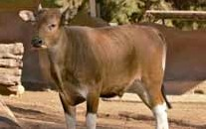
2001 2003 2009

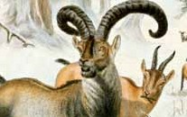
aNT PhOTO liBRaRy/sCiENCE sOURCE (FROG); GEORGE layCOCk/sCiENCE sOURCE (PiGEON); sTR NEw/REUTERs (2001); saN diEGO ZOO (2003); wikimEdia COmmONs (2009)
Researchers clone the first domestic cat. The kitten is named cc, for “Copy Cat.” some companies begin offering to clone pets—but it’s very expensive.

Cells from a dead banteng, a type of wild asian cattle, produce a healthy cloned calf—raising hope that cloning can help save endangered species.

scientists report that they used frozen cells to clone the bucardo, an extinct spanish goat. But the clone, born with lung defects, lived only seven minutes.

to order, call 1-800-scholastic 4

